MagSafe

A Revolutionary Wireless Charging Technology

## Abstract

Overall, Apple's MagSafe is a wireless charging system. This revolutionized the process of powering up our devices. The goal of this report is to understand the design operation of MagSafe as well as the Physics laws that contain in this.

## History

There are 2 types of MagSafe, one is for charging Macs while the other is specifically for iPhones. In this report, we only care about MagSafe for iPhones because they have significantly different technologies from Macs.

A MagSafe cable was introduced for Macs in 2006. The MagSafe charging cable was an innovative solution that attached to MacBooks using magnets. This ensured a secure connection and prevented your laptop from dropping. Around the time that USB-C charging became available for Macs in 2016, MagSafe was discontinued. It made an outstanding comeback in 2021 with the 14-and 16-inch MacBook Pro models, and again in June 2022 with the all-new MacBook Air.

Considering Apple also dubbed their method for automatically charging the iPhone 12 from 2020 onwards MagSafe, it's evident the company liked the moniker.

## Introduction

These days, wireless charging is an important part of many electronics because it is simple and easy to use. MagSafe, which came out in 2020 and is a big step forward in wireless charging, made things easier and better for users.

After the iPhone 8, it was possible to charge the phone both wirelessly and with a plug. Apple first used the Qi standard, which is widely used. The back of your iPhone was put on a Qi charging pad. When the pad's coil was lined up with the back of your iPhone's coil, wireless charging would start.

It was simple to get the coils misaligned, which meant that charging would be very slow or not connect at all. This meant that you would often wake up to a dead phone, even if you had left it charging wirelessly overnight.

A clever solution was developed by Apple and named MagSafe. Magnetic is what the "Mag" stands for. The Qi charging coil is enclosed in a ring of magnets in every iPhone from the 12 or 13 or 14 even 15 generation until now. Therefore, these iPhones are compatible with charging accessories.

## General understanding

Magnetism: The magnetic connection is the most vital part of MagSafe. Magnets are used to line up the connection with the device so it can be securely attached. The magnetic field makes sure that the link is strong enough to stay in place, but it í also easy to break if needed. This magnetic orientation is very important for making sure the device is in the right place, especially when charging because it helps line up the charging coils correctly or we will get a phone with 0% battery after a long period of time charging.

Electricity: After the magnetic connection placed correctly, electricity can be easily used to charge. When the device is being charged, the MagSafe charger is magnetically connected to it. This lets electricity flow from the charger to the battery. Within inductive charging, an electric field moves power between them.

In general, MagSafe is a creative way to use both magnets for physical alignment and connection and energy for charging.

## How does MagSafe work for iPhone?

The Apple-designed MagSafe wirelessly charges compatible gadgets, by combining the concepts of electricity and magnetic. A crucial part of the MagSafe system is the incorporation of magnets into both the device and the charging accessories.

A ring of tiny magnets encircles the charging coil inside the iPhone. There is an identical magnetic ring in the MagSafe charger that corresponds to this one. The magnets in the iPhone and the MagSafe charger attract each other when you bring them near to the back of the phone, guaranteeing a safe and exact alignment.

In order to charge efficiently, especially with rapid charging capabilities, the alignment is critical. For the MagSafe charger and iPhone to work together as intended, the charging coils must be precisely aligned. Although certain iPhone models, like the 12 mini and 13 mini, may have a 12W restriction, this exact alignment enables charging rates of up to 15W.

Magnets have a dual purpose: they help in aligning the charging coils and they improve the user experience in general. The MagSafe charger's magnets form a tight bond with the iPhone when it slides onto the device, and the iPhone could show a short animation pertaining to the accessory to verify the attachment.

Pair of electromagnetic coils, with one of them connected to a power. They come together and create a magnetic field which mean the power is wirelessly trasmitted. It is a process called Electromagnetic Induction.

Wireless chargers have one of those electromagnetic coils: transmitters ,while all phones that support wireless charging also have built-in coils: receivers.

In contrast, on the iphone 12 series is a system of magnets and other parts that enable this new feature called Magsafe.

In addition, comparing to the time to use Magsafe with Wired charger for charging from 0% to 100% with an average charging efficiency of around 80%, we can estimate:

$$Charging time=\frac{Battery capacity}{Charging power x Charging efficiency }$$

We assume that the iPhone 12 has a battery capacity approximately 2815 mAh. Using the formula above we have it took around: 234.58 minutes, so it might take around 3 hours and 54 minutes to charge an iPhone 12 from 0% to 100% using a 15W MagSafe.

If you have a power adapter that is 18W or more and a USB-C to Lightning connector, you can quickly charge your iPhone 12. Assuming the charging efficiency is the same, the time is to make an iPhone fully charged: 195.49 minutes.

The cable charging technique seems to be somewhat quicker than the MagSafe charging method. Note that these are just approximations, and that there are a number of variables that might cause the actual charge.

What is more, A surface's magnetic flux, represented by Φ, is the amount of magnetic field that passes through it. Coil alignment affects magnetic flux and, by extension, power transmission efficiency in MagSafe.

The induced current is always going to be in opposition to the change in magnetic flux, according to Lenz's Law. When designing MagSafe, this rule was taken into account to provide maximum efficiency with minimum energy loss.

Coulomb's Law is also crucial for understanding the electromagnetic forces involved in Magsafe. Coulomb's Law explains the force that exists between charged particles.

## What Magsafe can be seen in the future?

Using MagSafe technology with an iPhone improves the device's performance and the user's overall experience in a number of important ways. The MagSafe feature for iPhone has many important advantages, including the following:

Quicker Charging: Compared to regular Qi wireless charging, MagSafe with 15W power supply capability for the iPhone is significantly faster. This makes charging times faster, which is convenient and comfortable for consumers.

Protecting Data: MagSafe chargers and accessories have built-in safeguards to prevent data loss or theft when charging. The correct control of heat and a tight attachment to avoid unintentional separation when charging are essential.

User experience: It is substantially improved since it is now easy to attach accessories to the rear of the iPhone without worrying about alignment. The process of connecting and removing accessories is made simple and satisfying.

There is room for future development in Apple's MagSafe technology to provide other features, such as the ability to integrate with other smart devices and accessories or facilitate rapid data transmission. Also, this kind of technology should broaden to other ecosystem like Samsung or Xiaomi although they have already had it since very long ago.

## Conclusion

Finally, wireless charging has never been easier than with MagSafe, which combines magnetic alignment with inductive charging for a fast, accurate, and convenient charge. MagSafe is well-positioned to revolutionize wireless charging and establish new benchmarks for efficiency and portability.

Until now, Magsafe is not only a wireless charger, you can add a variety of accessories to your Magsafe, making it more than just a wireless charger. A magnetometer and a single-coil near-field communication reader are two of the new features that allow the iPhone 12 to connect with accessories in a completely different manner.

## Images

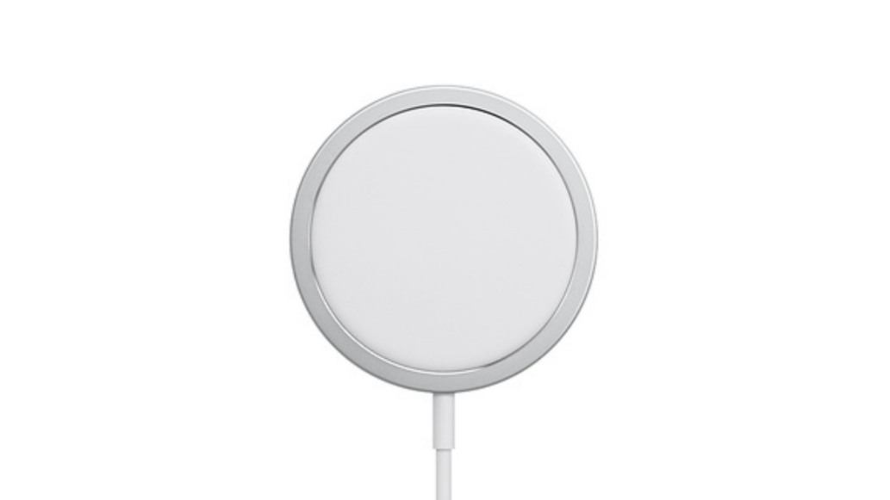

*Source: https://images.macworld.co.uk/cmsdata/features/3607036/magsafe_charger_thumb.png*

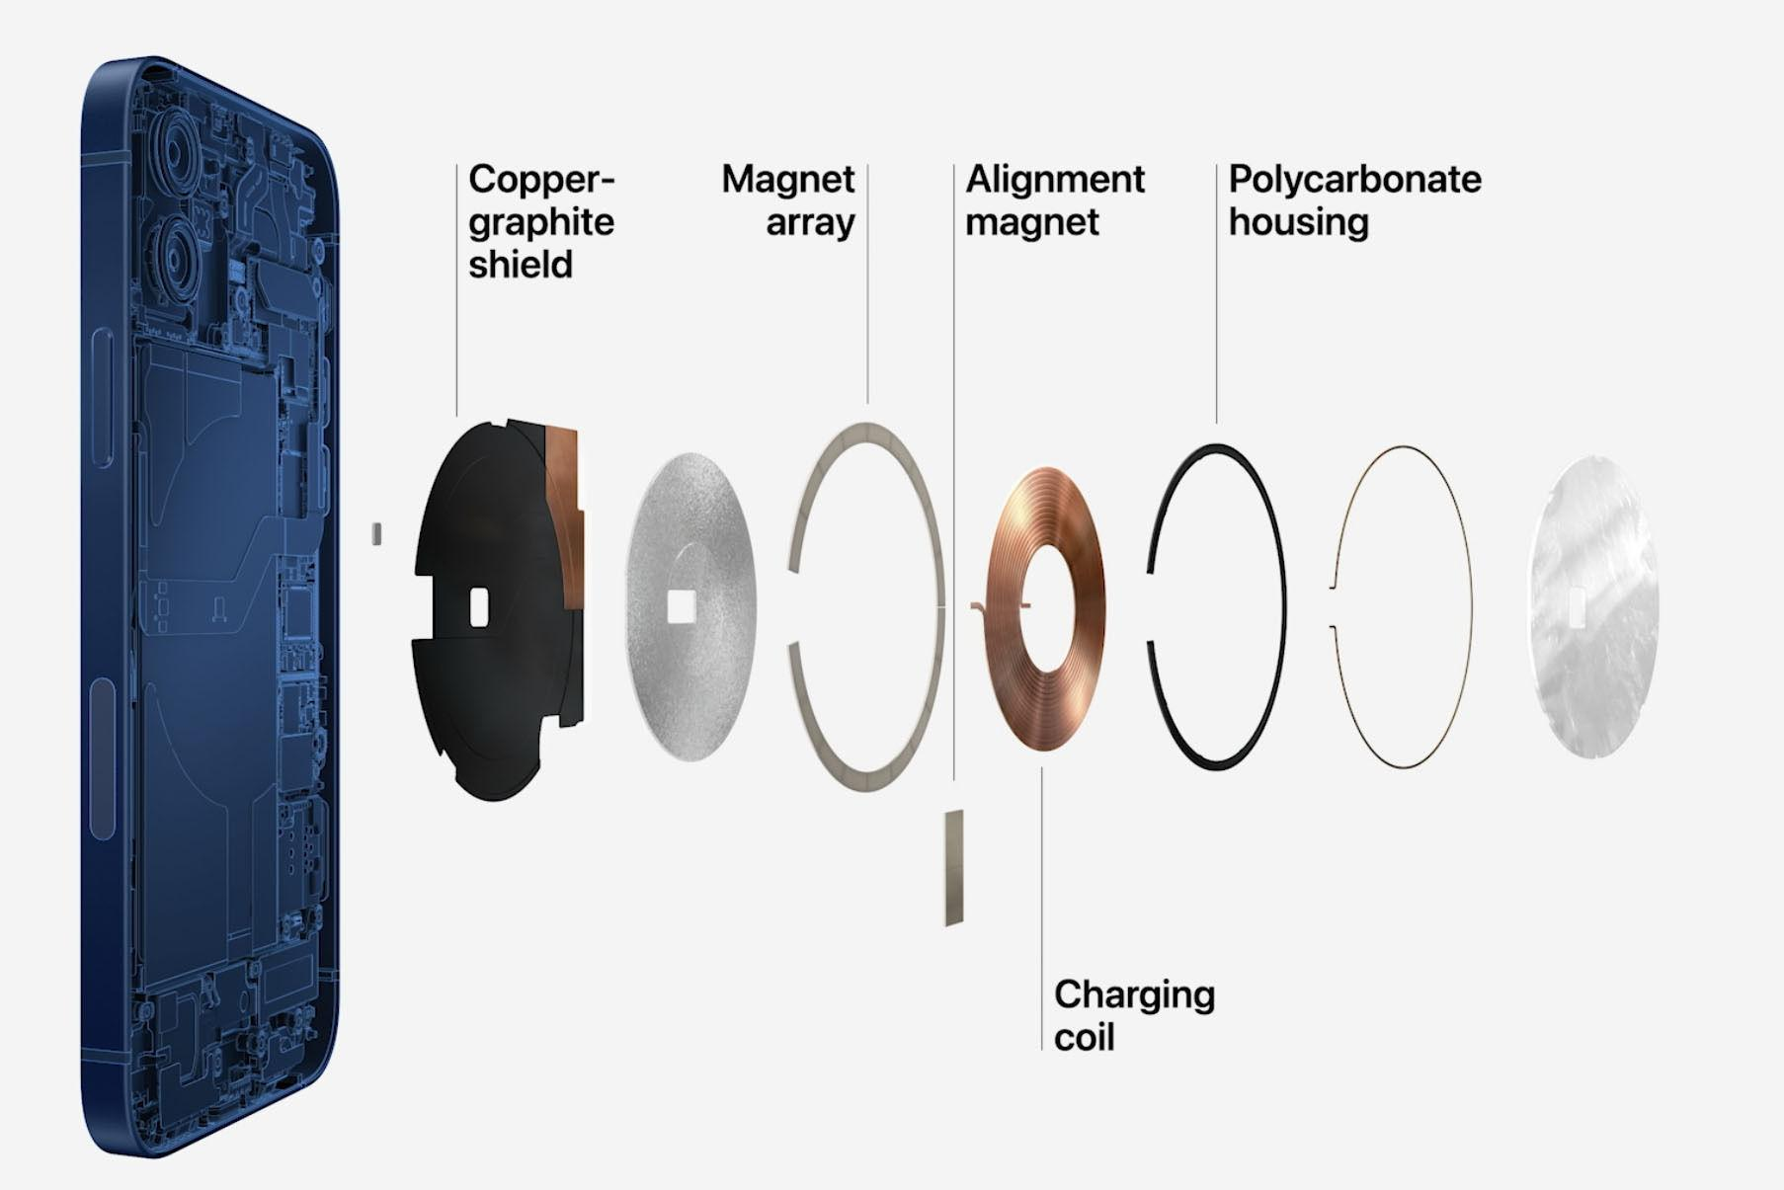

*Source: https://images.macworld.co.uk/cmsdata/features/3607036/iphone-12-magsafe-100862047-orig_thumb.jpg*

## References

* [Guide to Apple MagSafe on iPhone and Mac: What is MagSafe? | Macworld](https://www.macworld.com/article/671596/complete-guide-to-apple-magsafe-what-is-magsafe.html)
* [MagSafe (wireless charger) - Wikipedia](https://en.wikipedia.org/wiki/MagSafe_(wireless_charger))
* [Apple's MagSafe for iPhone: How it works, accessories and more - CNET](https://www.cnet.com/tech/mobile/apples-magsafe-for-iphone-how-it-works-accessories-and-more/)
* [What MagSafe on the iPhone 12 is, how it works, and what can it do | AppleInsider](https://appleinsider.com/articles/20/10/14/what-magsafe-on-the-iphone-12-is-how-it-works-and-what-can-it-do)
* [What Is MagSafe and How Does It Work? (makeuseof.com)](https://www.makeuseof.com/what-is-magsafe/)
* MagSafe Explained - GadgetMatch